Ethics of Wildlife Management and Conservation: What Should We Try to Protect?

What should we protect when managing and conserving wildlife? There's no single answer. Competing values, and different prioritizations of values create ethical dilemmas and disagreements.
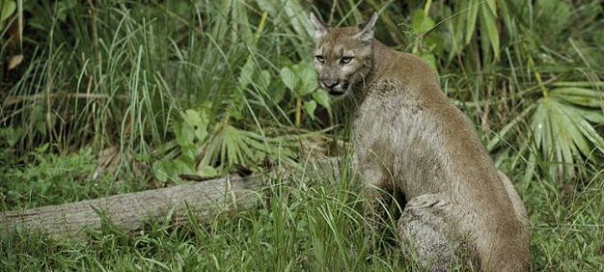
Expanding human demands on land, sea and fresh water, along with the impacts of climate change, have made the conservation and management of wild areas and wild animals a top priority. But there are many different reasons for thinking that such conservation is important, and these reasons can shape conservation policies in different ways. Here we'll explore some of the different underlying values that can direct conservation policy, and explain how they can create ethical dilemmas and disagreements.
Wild animals have always been a critical resource for human beings. Historically, food, fur, and leather were key to human survival — more recently, wildlife has assumed high economic and cultural significance. Wild animals provide entertainment in circuses, zoos, and wildlife parks, they form a central attraction in international tourism, and they are key members of ecosystems on which humans rely for vital services. Equally, wild animals can be seen as threatening to human beings; for instance, they can be sources of new human diseases (zoonotics), and they can damage or consume human crops. What matters here, whether as resource or threat, is how useful — or otherwise — wildlife is to human beings. Environmental ethicists often call this instrumental value.
In modern debates about wildlife, however, other values have become increasingly important. One focus is on animal welfare — the wellbeing of individual wild animals (e.g., in terms of animals' flourishing, or suffering). There are also concerns about protecting species or populations of wild animals, about protecting the ecosystems of which wild animals form a part, and about protecting wild nature itself (Sandøe & Christiansen 2008). The wellbeing of individual animals matters less where species, ecosystems, or wild nature is emphasized — indeed, painful predation may be understood as promoting ecosystem health, or as applying the right kind of selective pressure on a species as a whole.
Although the idea of "wildlife" is usually taken to mean animals not bred or controlled by humans, increasingly, wild animals are not just left alone to live their own lives (Gamborg et al. 2010). In response to pressures on wild animals and their habitats, a nature and wildlife protection movement has grown over the last two centuries. Often this protection has taken the form of active wildlife management, where some species are controlled as part of a policy to promote the success of other species.
This raises key questions about the responsibilities we have to wild animals. What should we try to protect? How should we balance different, potentially conflicting, values such as nature protection and individual animal welfare? First, we'll give an overview of wildlife management values central to these debates. Then we'll outline five different possible ethical perspectives through which it is possible to think about wildlife management and conservation.

Developments in the Use and Management of Wild Animals
Human attitudes towards wild nature and wildlife have, historically, been ambivalent. Prehistoric societies of hunters and gatherers seem to have understood wild animals not only as a source of food and fur but also — cave paintings suggest — as objects of reverence. And while a dominant strand of the Judaeo-Christian tradition understands animals purely as human resources, other Christian traditions — such as St Francis' celebration of animals as "brothers and sisters" — interpret the value of animals very differently (White 1967). Ideas about wilderness have likewise been complex and ambivalent: wilderness has been both understood as dark, chaotic and fearsome, but also as unsullied, a place of sublime beauty and spiritual purification.
The idea of the purity, beauty, and special significance of wild places became increasingly dominant in the nineteenth century. It served to underpin the foundation of the US National Parks system, and eventually the US Wilderness Act of 1964. However, a variety of different and potentially conflicting values, also played role — and still do — as a basis for such initiatives to protect wild nature.
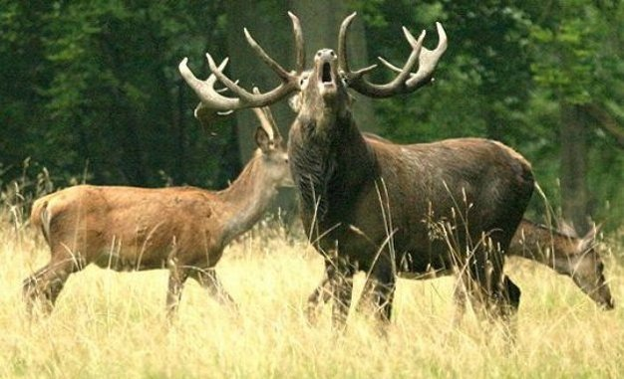
Red Deer (Cervus elaphus).
Mature males (stags) compete for the attention of the females (hinds) in the mating ritual (rut) period by producing the loudest roar. The management of deer is an important ethical concern in many countries, generating ethical disagreements in which human preferences, concern for individual animals, the value of biodiversity, and wild nature have to be balanced.
© 2012 Nature Education All rights reserved.

Values at stake in wildlife management.
Two main approaches to wildlife management — and nature management in general — can be identified: the wise use of nature, and the preservation of nature. These two approaches both reject the unthinking marginalization or destruction of wildlife. But when it comes to the actual management of wildlife and nature, the two approaches differ. The wise use approach aims to accommodate humanity's continuous use of wild nature as a resource for food, timber, and other raw materials, as well as for recreation. The idea of wise use appeals to our own best interests, or to the interests of humans over time, including future people (this approach is often called "sustainable use"). The goal of management is to enhance and maintain nature's yield as a valuable resource for human beings.
For the preservationist, on the other hand, the goal is to protect pristine nature, not to use it, carefully or otherwise. If human intervention has damaged wild nature (for instance by pollution) then projects to restore nature to something like its former state may be permissible. But aside from genuine restoration cases, from a preservationist perspective, wild places should be allowed to develop on their own with as little interference from humans as possible. The "otherness" or "naturalness" of the non-human world is what's valued here. The only use humans should make of protected areas is for recreation, and only then if recreation leaves no trace behind.
More recently, values beside resource values and the value of "untouched" nature have become increasingly important in wildlife management. These include the value of whole ecological systems, the value of species, and in particular, the importance of animal welfare. We'll discuss these in more detail below.

Dilemmas and conflicts.
These different values give rise to conflicts or dilemmas. For instance, there may be a conflict between sustaining certain human livelihoods and preserving a particular species, or there may be a dilemma between the protection of wild nature and animal welfare. The question, then, is how we should address such dilemmas and disagreements. We'll now outline five different possible ethical perspectives on these problems, drawn from within environmental and animal ethics.

Underlying Ethical Approaches to Wild Animals: Five Perspectives

A contractarian perspective.
Contractarianism is an influential group of ethical approaches which maintain that morality has emerged — or should emerge — from humans making agreements or contracts among themselves. Such contracts can ensure the protection of individuals, allow them to gain benefits from co-operation, and by protecting and promoting individuals' interests, also create a good society. But animals can't make contracts. Thus, from a contractarian perspective, wild animals fall outside the ethical sphere and are, essentially, a resource for human use. On this view, the main ethical constraint on wildlife management is to make sure that wildlife is used wisely, for human benefit, in ways that humans can agree to. Since effective protection of nature and wildlife often requires coordinated action at a global level, there may, from a contractarian perspective, be very good reasons to support binding international agreements on the protection of endangered wildlife species. However, the long-term goal would always be to enable wildlife to be used for human purposes.

A utilitarian perspective.
Utilitarianism is a form of consequentialism, an ethical theory based on the idea that we should aim to bring about the best outcome overall, taking into account everyone affected by the decision. For utilitarians, welfare — defined either in terms of pleasure or in terms of preference or desire satisfaction — is the primary value, and pain, or the frustration of desires, the primary disvalue. So, we should aim to minimize total pain or frustration and maximize total pleasure or desire satisfaction overall. Since animals of the kind we are considering here can suffer, we should take their suffering — and consequently, their welfare — into account in our management decisions. This view has significant implications for wildlife management. Take hunting, for example. In some cases, sport hunting would be morally unacceptable for a utilitarian, as it is likely to cause animal pain without producing comparable benefits to humans. But other kinds of hunting may be permissible, or even required. Suppose a deer population has grown so large that there is insufficient food to support it, causing all the deer to suffer and starve. In this case, culling some deer as painlessly as possible is likely to reduce animal suffering overall. What matters here, then, is how far wildlife management reduces or increases the overall level of animal and human welfare.

An animal rights perspective.
Animal rights theorists, such as the philosopher Tom Regan (1983), maintain that humans and certain other animals share critical similarities (such as being able to feel pain and having desires about their future). These shared capacities, on this view, underpin the possession of moral rights. And if an animal has rights, there are some things we may never do to it. In the case of wild animals, we should not kill, confine, or otherwise interfere in their lives. It is neither our right, nor our duty, to cull, nor in other ways to manage, wild animals. Nor may we take away the land and other resources that wild animals require to live natural lives. This does not mean that we cannot defend ourselves against wild animals if attacked — after all, we're permitted to defend ourselves against other humans. And, if necessary, habitats could be managed, provided animals were allowed to continue living the kinds of life they have evolved to live. But in general, a wildlife policy determined by an animal rights perspective would direct us just to leave wild animals alone.

Respect for nature perspectives.
"Respect for nature" really refers to an overlapping group of views, concerned with values other than those possessed by individual sentient living beings (by sentient, we just mean those beings with the ability to suffer or have other subjective experiences). Some of these views focus on protecting the value of naturalness itself. Others focus on the preservation of whole species, on protecting the "integrity" of species, or on biodiversity. Yet others argue that native ecological communities, or ecosystems, are of moral importance in themselves and should be preserved for this reason. This view was most famously proposed by Aldo Leopold — who became the first US professor of game management in 1933 — in his posthumously published essay collection A Sand County Almanac (1949). On all these "respect for nature" views, the moral importance of individual animals depends on how far they promote or threaten the key environmental values at stake. So members of keystone species in an ecosystem will be particularly important, while members of an invasive species that threatens either native species, or ecosystem health, should be removed or killed.

A contextual (or relational) view.
This is a group of associated views that share an emphasis on the ethical importance of human-animal relationships. On this approach, humans have rather different relations — and hence moral obligations — to wild animals than they have to domestic ones (Palmer 2010). This is not, primarily, due to differing human emotional responses to animals in such different contexts — though these may be a consideration. Rather, it is because humans are responsible for the very existence of domestic animals (unlike wild ones), and, additionally, through selective breeding, for their natures — and because this often renders the relevant animals dependent and vulnerable in ways wild animals are not. So, while we may have duties to assist hungry or suffering domesticated animals, such special obligations to help animals don't normally form part of wildlife management.

Hybrid views.
Given the plausibility of many of the values at stake, it's difficult to "choose" one of the above approaches, and thereby to reject the rest. A hybrid view attempts to combine at least some of these values. One important hybrid view is "ecological ethics". This view argues for the creation of a comprehensive pragmatic and pluralistic ethical framework, with a case study database, on which research scientists and conservation managers can draw when complex moral questions arise. This pluralistic ethical framework should incorporate different approaches to ethical theory, research ethics, and both environmental and animal ethics (Minteer & Collins 2005). The American philosopher Bryan Norton (Norton 2005) also develops a hybrid approach, distinguishing between animals in the wild context, in the domesticated context, and in mixed contexts (zoos, wildlife parks, and the like). Norton argues that we have implicitly taken on an obligation to care for the needs of domesticated animals and we should not, therefore, sacrifice the individual for the good of animal populations or species. But in the case of wild animals, he argues, we should respect the struggle of wild animals to perpetuate their kind, as well as to protect their own lives. Respect for this struggle may permit us to sacrifice the interests of the individual wild animal for the good of the animal population. Certainly, Norton's view has intuitive appeal, but both a utilitarian and a rights perspective, would question the kind of respect involved in our sacrificing individual animals for the sake of a population.

In Conclusion: Balancing Concerns
The management and use of wild animals generates ethical disagreements and dilemmas in which human needs, preferences, and interests, concern for individual animal welfare, and the value of biodiversity, ecosystems, and wild nature are part of the discussion. The way in which these different values are prioritized will determine policy. We have not set out to make any particular recommendation. However, we do maintain that explicit consideration of the values at stake should underpin careful debate about, for instance, whether constant human involvement in nature reserves and other wild areas is desirable, and what constitutes "good" and "bad" human interventions in relation to wildlife.

